PROFILE AS AN AGRICULTURAL EXPERT AS A FACILITATOR FOR THE IMPLEMENTATION OF AGRICULTURAL ACTIVITIES UNDER THE FORUM FOR CHINA-AFRICA COOPERATION (FOCAC)

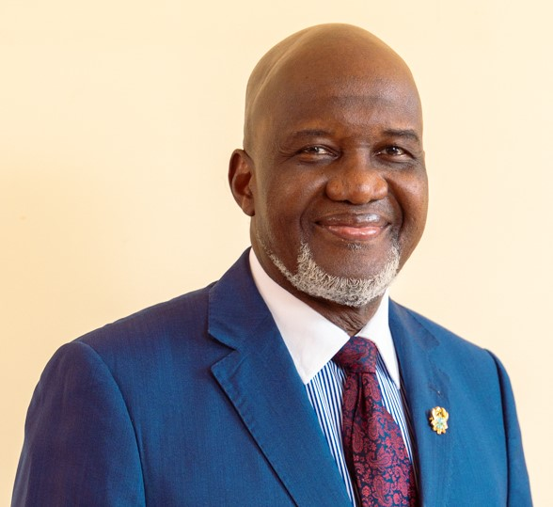

Winfred Nii Okai Hammond (Dr)

- Education
- 1998: Graduate Diploma (Organization Development) at the Gelstat Institute - University of Cleveland, Ohio USA with field consultations in Scotland, Netherlands, Israel, United States, and Spain.
- 1988: PhD (Natural Science/Entomology) at the University of Leiden, Netherlands. Thesis: Biological Control of the Cassava mealybug (Phenacocus manihoti) by the Encyrtid parasitoid Epidinocarsis lopezi in Africa.
- 1983: M.Sc. (Zoology/Entomology) University of Ghana, Legon / International Institute of Tropical Agriculture, Ibadan – Nigeria. Thesis: Ecological Assessment of cowpea (Vigna unguiculata) pests in Northern Nigeria.
- 1978: B.Sc. (Agriculture) University of Ghana, Legon

- Work Experience
- 2017-2018: Consultant/Advisor for Technologies for Africa Agricultural Transformation of the Africa Development Bank/ International Institute of Tropical Agriculture
- 2012-2015: Core Team Member: FAO Strategic Programmes Development Senior Plant Production and Protection Officer at the UN FAO resident in Zimbabwe working in all SADC countries (Angola, Botswana, Democratic Republic of Congo, Madagascar, Malawi, Mauritius, Mozambique, Namibia, Seychelles, South Africa, Tanzania, Zambia, Zimbabwe.
- 2012-2015: Senior Plant Production and Protection Officer at the UN FAO. Working in and out of Rome Italy in Madagascar, Lesotho, Haiti, Jamaica, Lebanon
- 20011-2012: United Nations Food and Agricultural Organization Country Representative in Rwanda.
- 2006-2011: United Nations Food and Agricultural Organization Country Representative in Liberia.
- 2005-2006: Deputy Minister, Ministry of Food and Agriculture, Ghana
- 2003-2005: International Consultant
- Project Development/Management (Agriculture and Rural Development)
- Integrated Pest Management (IPM)
- Project Monitoring and Evaluation
- Organization Development Interventions including Leadership and Team building, Conflict Prevention, Resolution, and Management
- Conference/Workshop Facilitation and Moderation
- 2004 (May-November): FAO Consultant (Team leader for Farmer Field Schools Project) in the 3 northern provinces of the Republic of Cameroon.
- 1994-2002: Senior Scientist / Regional Coordinator/Project Manager of African Cowpea Program (PRONAF) at International Institute of Tropical Agriculture (IITA)
- 1991-1996: Senior Scientist /Regional Coordinator for Technology Transfer and Training at the Biological Control Centre for Africa at International Institute of Tropical Agriculture (IITA)
- 1988-1991: Associate Scientist/Regional Coordinator for Biological Control in West and Central Africa at IITA
- 1983-1988: Junior Scientist at IITA (Biological Control Release and Survey Specialist)
- 1981-1983: Research Scholar at the International Institute of Tropical Agriculture
- 1978-1980: Research Assistant and Officer-in-Charge at the University of Ghana Agricultural Research Station, Kade.

C. PROFESSIONAL BODIES
- Life member of the African Association of Insect Scientist (AAIS)
- President of the African Association of Insect Scientist (1993-1997)
- Life member of the International Society for Tropical Root Crops (ISTRC)
- Former member of the American Entomological Society and the
International Organization of Biological Control

D. LANGUAGE PROFICIENCY
- English: Excellent in written and spoken English.
- French: Fluent in French as a working language. Working experience with all francophone countries in West and Central Africa for more than 20 years.

E. HIGHLIGHTS OF EXPERIENCE AND ACHIEVEMENTS
- As a Consultant/Advisor (2017-2018) for Technologies for Africa Agricultural Transformation (TAAT) of the Africa Development Bank/ International Institute of Tropical Agriculture which is ongoing, he contributed to bring together research institutes (national and international), public extension services, private sector suppliers and buyers, farmers organizations and not-for-profit organizations involved in agricultural development, aimed to help the continent fulfil its enormous potential in the sector by employing high-impact technologies to boost output, through the deployment of proven and high performance agricultural technologies. The programme set the ambitious target of reaching 40 million farmers in five years and adding 120 million metric tons of additional foodstuffs in the African food basket.

The overall goal of TAAT is to radically transform African agriculture into a competitive sector by deploying productivity enhancing technologies and focusing on 8 Priority Intervention Areas (PIAs), namely:
- Self-sufficiency in Rice Production
- Cassava Intensification
- Food and Nutrition Security in the Sahel
- Transforming African Savannahs into Breadbaskets
- Revitalizing Tree Plantations
- Expanding Horticulture
- Increasing Africa’s Wheat Production
- Achieving Self-sufficiency in Inland Fish Production

- United Nations International development experience (2006-2016) includes the following:

- As FAO Country Representative, provided advice, leadership and strategic guidance on managing multilateral programmes, multicultural teams and interdisciplinary advisory services in fields such as institutional capacity development in food and nutrition security.

- Specialized executive and advisory experience in programme formulation, management and implementation, and funds mobilization for emergencies, gender-related programmes including the US$22million Danish-funded women empowerment food and nutrition security project in Liberia (2008-2011), and about US$3.5 million value-chain projects on rice and cassava in Liberia (2009-2011), etc.,

- Facilitated international cooperation and strategic partnerships with bilateral development agencies and governments, multilateral agencies such as other UN Agencies, IFAD, Africa Development Bank, World Bank, USAID, DFID, etc.,

- Ministerial Experience

- As Deputy Minister of Food and Agriculture, led various programmes, initiatives, and managed high-level consultations and negotiations. Also facilitated international cooperation and strategic partnerships with bilateral and multilateral development agencies such as the FAO and other UN Agencies, the World Bank, USAID, DFID, AU, ECOWAS, and NEPAD. He was the key focal person for the development of agriculture-led youth employment programmes in Ghana. He led various delegation missions to Asia, Europe, the United States, and other African countries.

F. ACHIEVEMENTS & AWARDS

- Contributed to the achievements of the agriculture sector that won the World Food Prize of 2011 presented to the then President of Ghana, H. E. John Agyekum Kufuor

- Was decorated by the President of Liberia, H. E. Ellen Johnson Sirleaf, for contributing significantly to the positive changes in the Agricultural sector after a protracted civil war. One of the key achievements was developing programmes that led to the increase of rice production from 80,000tonnes to 200,000 tonnes in 4 years (2006-2010).

- As Senior Scientist whose Applied Research led to the Successful implementation of Classical Biological Control of the Cassava Mealybug (CM), with a saving of about US$2.2 billion to farmers and consumers in Africa. This research and development work contributed significantly to the following awards:

- King Boudowin Award in 1990,
- World Food Prize Award presented to the then leader of the Team, Dr Hans Herren in 1995.

G. RELEVANCE OF EXPERIENCE TO THE IMPLEMENTATION OF ECONOMIC/RURAL REVITALIZATION AND MODERNIZATION OF AGRICULTURE

The Technology for African Agricultural Transformation (TAAT), funded by the African Development Bank, is to develop food value chains through African Economic Regional Communities in selected African countries. TAAT is aligned with the objectives of the Comprehensive African Agricultural Development Programme of the African Union Commission’s NEPAD, namely to:
- Eliminate extreme poverty
- End hunger and malnutrition
- Turn Africa into a net food exporter, and
- Position Africa at the top of agricultural value chains where it has a comparative advantage

And could provide the foundation for Action Area 2 of FOCAC 2021 on Economic Cooperation. This will enhance opportunities for China and Africa to work together towards a more prosperous future by jointly supporting rural revitalization to improve the conditions of basic infrastructure, including roads that link urban and rural areas, small water management and irrigation facilities in villages and townships, food storage and basic processing facilities, renewable power facilities and small agricultural mechanization equipment for African countries.
Furthermore, China and Africa jointly acknowledge the need to share China’s experiences more actively and in a tailored way with African countries to stimulate new solutions to poverty reduction, and also believe the private sector can play an active role, for example through the 100- villages project, while facilitating more diverse and value-added agricultural exports to China in order to provide sustainable livelihoods for farmers.

In his career as an executive international agricultural expert and diplomat, Dr Hammond worked with and in more than 35 African countries over a period of 38 years. His experience as an agricultural technocrat in the areas enumerated above, enhanced by his broad diplomatic exposure could be an asset to the African Ambassadors Group in China in the implementation and coordination of the delivery on agricultural led economic/rural revitalization, among others.

